**Everything you ever need to know about your CBC: The ABC of CBC**

**What are RBCs?**

Do you know why your blood is red? Yes, it is because of red blood cells. The more the amount of red cells in your blood darker it is. If the blood is pale it means the blood is deficient in RBCs and haemoglobin indicating a condition called as *anemia*. Many times this paleness can be appreciated by looking at your palms, nail beds and eyes.

Red blood cells are small round cells containing haemoglobin and without a nucleus. On blood smear they like like a doughnut with a pale area in the centre. They are produced in your bone marrow and have a life of 120 days.

**What is Hemoglobin?**

Hemoglobin is a test done for the detection of anemia. Hemoglobin is needed to carry the oxygen that you breathe to the different parts of your body. If you are sufferening from anemia, your cells get less oxygen & less energy and you get tired very easily.

The most common way you can develop anemia is because of low essential nutritional elements like Iron (Iron deficiency anemia), Vitamin B12 & Folic Acid in your diet (Megaloblastic anemia). Sometimes there can be problem with the absorption of these elements in intestine or there can be excessive loss.

**What are RBS indices?**

Your RBCs are usually of the same size, shape and colour. However in certain anemia their size, shape and colour may vary which is the basis of differentiating various types of anemia. Thease properties are measured and reported in the form of RBC indices.

MCV (Mean corpuscular volume): Indicates the average size of the RBC

MCH (Mean corpuscular haemoglobin): Indicates the average amount of haemoglobin in each RBC

MCHC (Mean corpuscular haemoglobin concentration): It is the relative amount haemoglobin in proportion to the size of the cell.

Reference ranges:

* MCV: 80 to 100 femtoliter
* MCH: 27 to 31 picograms/cell
* MCHC: 32 to 36 grams/deciliter (g/dL) or 320 to 360 grams per liter (g/L)

**How these indices play a role in understanding of anemia?**

If the average size of the RBC is less then it is called as microcytic anemia. When it is more it is microcytic anemia. When the MCH is normal it is normochromic anemia, when it is decreased it is hypochromic anemia.

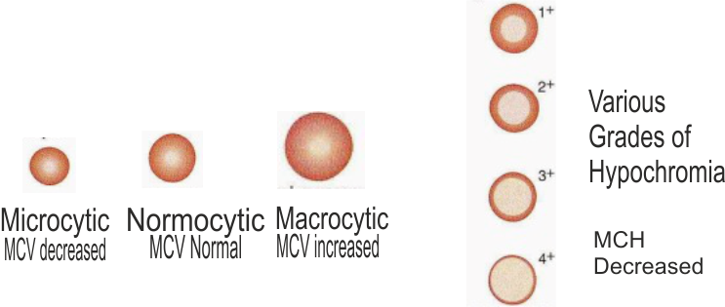

**What are WBCs?**

White blood cells (WBC) or Leukocytes, is the second important component of your blood and also your CBC report. If tomorrow there is an attack on your country, who is going to save you? Yes our soldiers. If there is attack on our body our body soldiers – The WBCs protects us. Whenever there is war, there is increase the number of military personnel. The same way whener there is infection there is increase the WBC count. In severe infection if many WBCs are killed the count may be less than normal.

In blood cancer (Leukemia) there is uncontrolled growth of WBCs & its number increases enormously.



**What is WBC differential count?**

WBCs are also produced and mature in bone marrow, except for the lymphocyte which also matures in lymphoid organs. There are 5 types of White blood cells in your blood. Neutrophills, Lymphocytes, Monocytes, Eosinophills and Basophills. Which particular type of white blood cell is involved in particular disease depends upon the cause and duration of the disease.

WBC diagram

**What are Platelets?**

Have you noticed when your body is pierced, it bleeds for few minutes & then the bleeding stops automatically. Why? The answer lies in platelets – The 3rd most important component of blood & your CBC report. Platelets act as cement & help in closing the gap in the injured blood vessel. Now you know why it bleeds when there is low platelet count, a condition called as thrombocytopenia. It is commonly seen in Malaria or dengue. What is the solution – transfuse platelets.

Sometimes the platelet count may be spuriously low the CBC report but normal in actual body. This happens because platelets have tendency to stick to walls and when there is delay in drawing the blood they get activated & stick to the vessel wall and the wall of the syringe. So the count is falsely low.

**What is meant by white blood: Leukaemia – the blood cancer**

Red is the colour of your blood and it is because of presence haemoglobin. In leukaemia the White blood cell count is so high that sometimes it is called as *white blood*.

Leukaemia in common man’s language is called as *blood cancer*. A patient is labelled as having blood cancer or Leukaemia when there is an uncontrolled and abnormal growth of white blood cells in the blood. The WBC count may be more than 1 lakh/cu.mm. (Norma count is 4-11000/cu.mm.)

There are 2 types of leukemia depending upon the onset of the disease 1. Acute Leukemia:It occurs suddenly 2. Chronic leukemia: It develops over a period of time. Also depending upon the types of the cells affected is classified as 1. Lymphoid leukemia: Cells of lymphoid BC series are affected. 2. Myeloid leukemia: Cells of myeloid WBC series are affected.

WBCs, which are the soldiers of your body, are diseased and dysfunctional. Now the body cannot fight infections and hence a patient of leukaemia suffers of repeated infections. All your blood cells are manufactured in the bone marrow. The uncontrolled WBC growth occupies all the marrow space. The development of red blood cells & Platelets is affected and patient suffers from anemia & thrombocytopenia.

Sometimes the patient is not even aware that he is some disease and leukemia may be accidently detected on peripheral blood smear examination, especially in cases of Chronic Lymphoid Leukemia.

Laboratory diagnosis of leukemia:

1. Complete Blood Counts (CBC): Increased WBC count may be more than 1 lakh & abnormal blast cells the blood smear are diagnostic of Leukemia.
2. Bone marrow examination: It again shows the uncontrolled growth of WBCs and blast cells are seen. The leukemia typing depending upon which series is affected and the number & types of blasts.
3. Other supportive investigations:Depending on the need Doctor many advice other tests like lymph node biopsy, USG, X-ray, Tscan/MRI scan or Karyotype & other genetic study etc.

Managemnet of leukemia:

There are many treatment options like 1. Chemotherapy. 2. Radiotherapy 3. Bone marrow transplant. Doctors decides the appropriate option depending upon the age, type of leukemia and the results of investigations.